Foster Alcantara

CISY 7013

LAB PORTFOLIO

Table of Contents

Module 2 Lab 3

Module 3 Lab 5

Module 4 Lab 10

Module 5 Lab 12

Module 6 Lab 13

Module 7 Lab 16

Module 8 Lab 18

Module 10 Lab 20

Module 11 Lab 21

## Module 2 Lab

**Using Online Tools**

Use the NsLookup tool at the Network-tools.com website to retrieve DNS records from the DNS server of the Fortune 1000 company you have targeted in Part 2 of this week's Peer Reviewed Assignment. Place a screenshot or screenshots into your lab portfolio showing the output from the NsLookup.

Target: Adobe.com

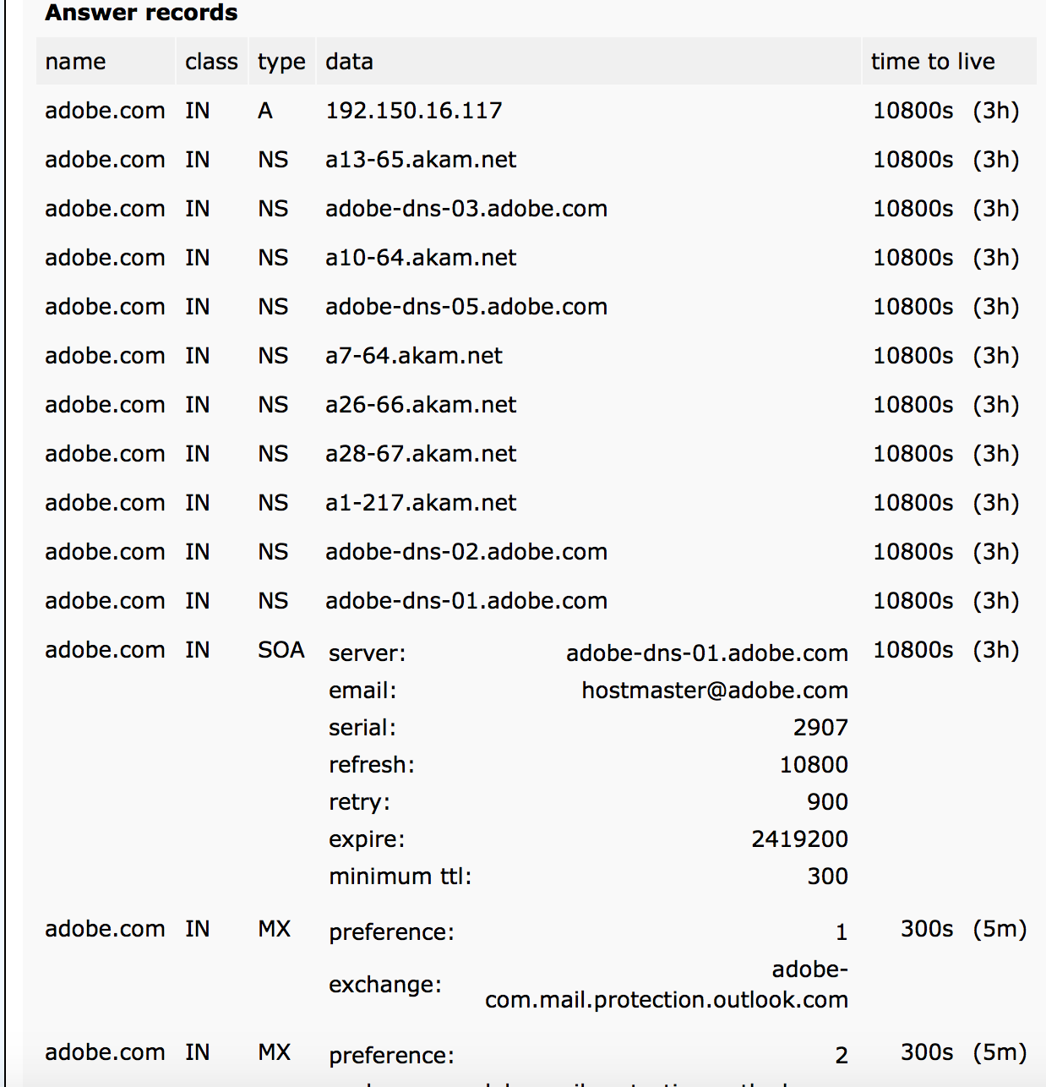

Repeat the above using the NsLookup tools at the following sites. You don't need to put screenshots into your lab portfolio for any of these. Did you get any additional useful information from any of these sites? If so, what?

I went and did a dns search on the three additional sites on adobe systems, but there was nothing extra other than an extra email server that was found on the search.

Repeat the above, entering the domain name into the DNSreport box at the following site. Did you get any useful information for either hackers or defenders from this report? If so, what? Place your answers into your lab portfolio.

<http://www.dnsstuff.com/>

There isn’t much on the website that is new that I haven’t already found. As far as what would be useful for a hacker, the email service is a great and useful thing to know. A hacker would now know what service the organization is using in order to stop their messages. A denial of service attack could be conducted.

Go to the following site. Change the lookup type from MX Lookup to DNS Lookup, DNS Check, and Domain Health. Do a search as above. Did you get any useful information from this site? If so, what? Place your answers into your lab portfolio.

<http://mxtoolbox.com/SuperTool.aspx>

There wasn’t anything new on this website that I haven’t found in my recent searches on the previous websites.

## Module 3 Lab

**Using nmap to scan a target computer**

Open the nmap command in Kali Linux and run each of the commands in the following list. Create a screenshot showing the output from each command.

**nmap –sT site1www.site1.com**

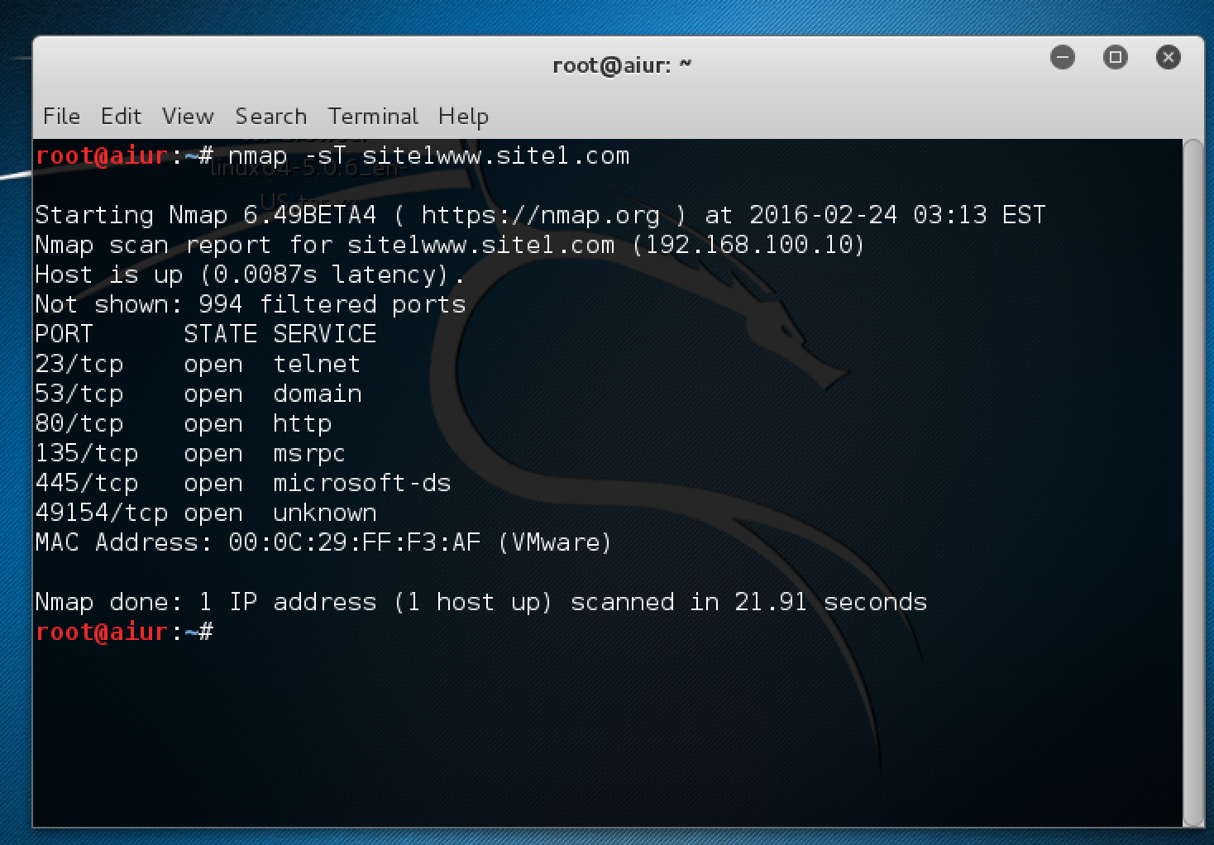

**nmap –sS site1www.site1.com**

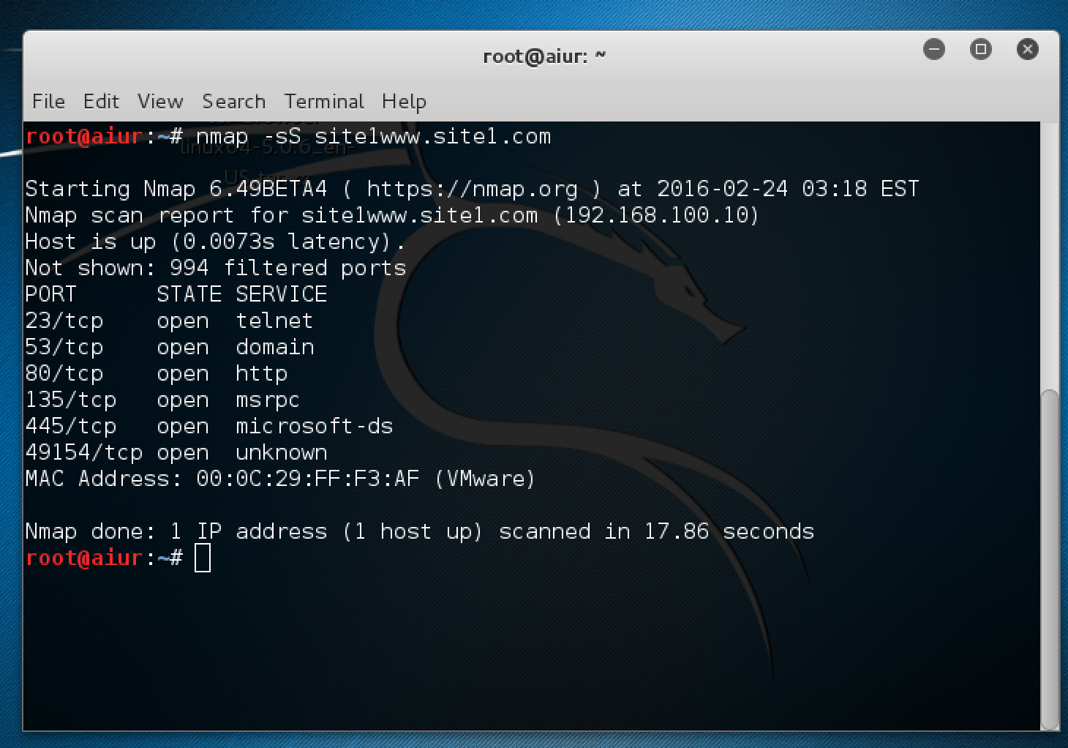

**nmap –sU site1www.site1.com**

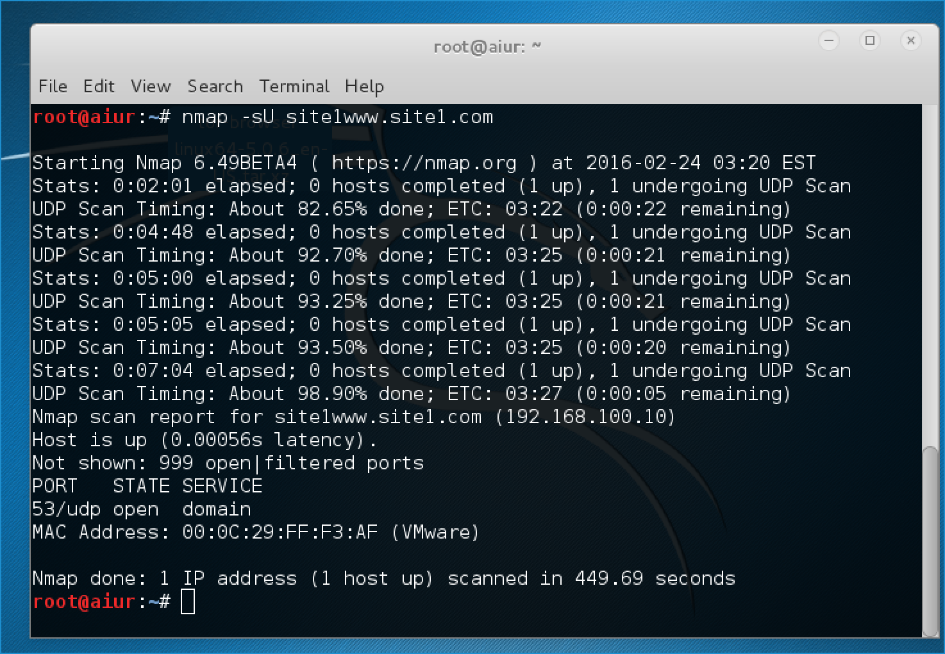

**nmap –sF site1www.site1.com**

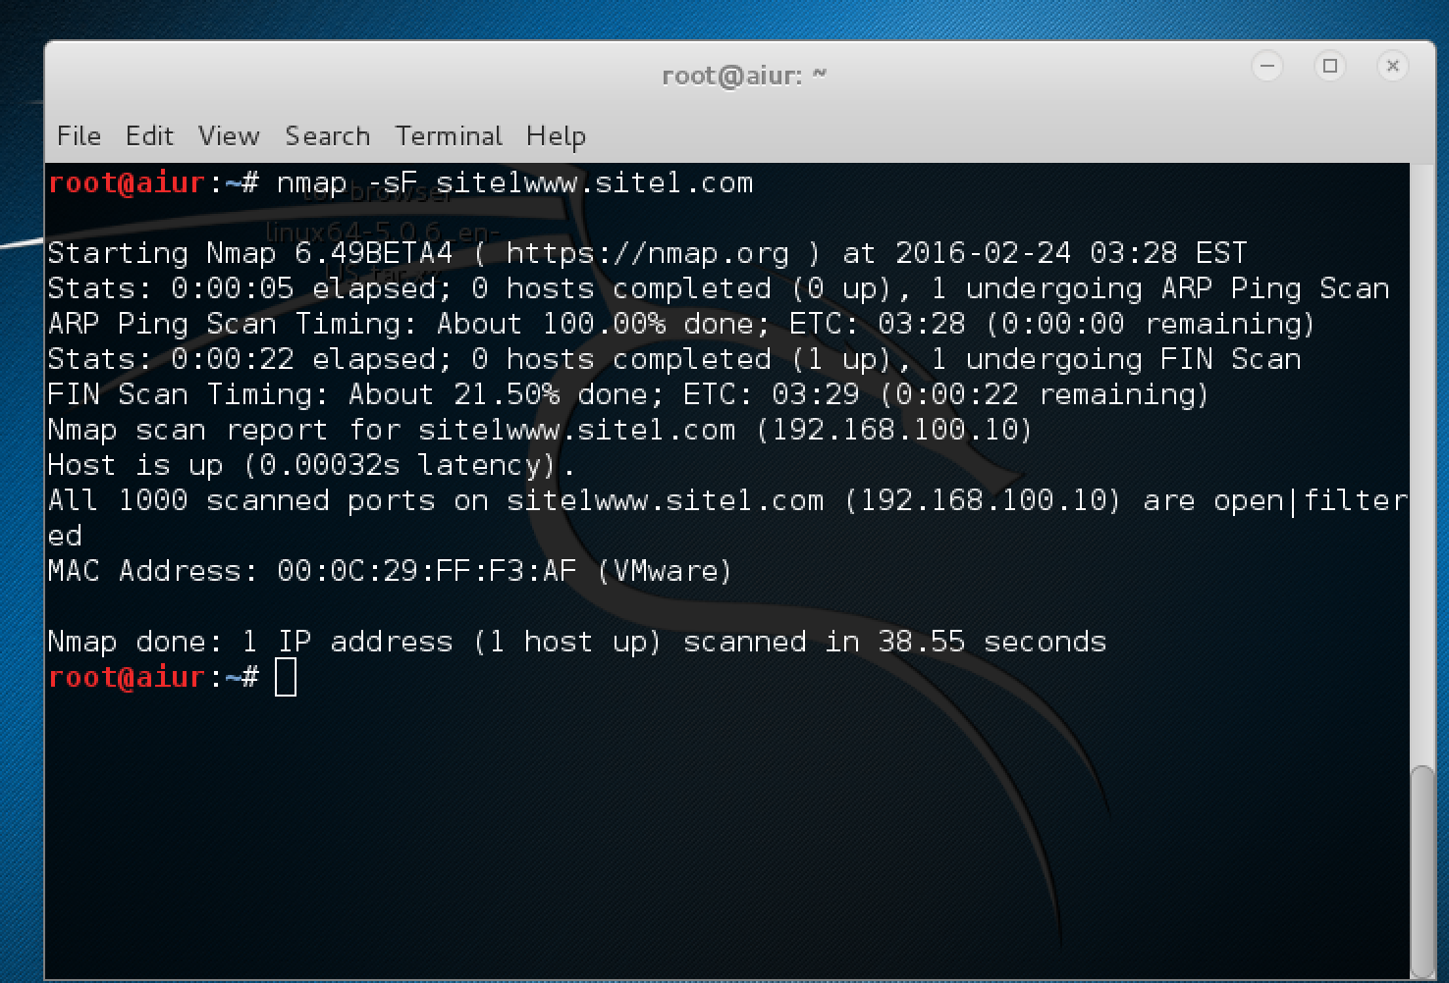

**nmap –O site1www.site1.com**

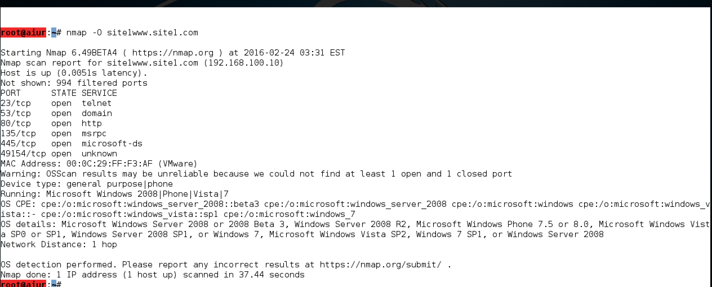

**nmap –p22 –O site1www.site1.com**

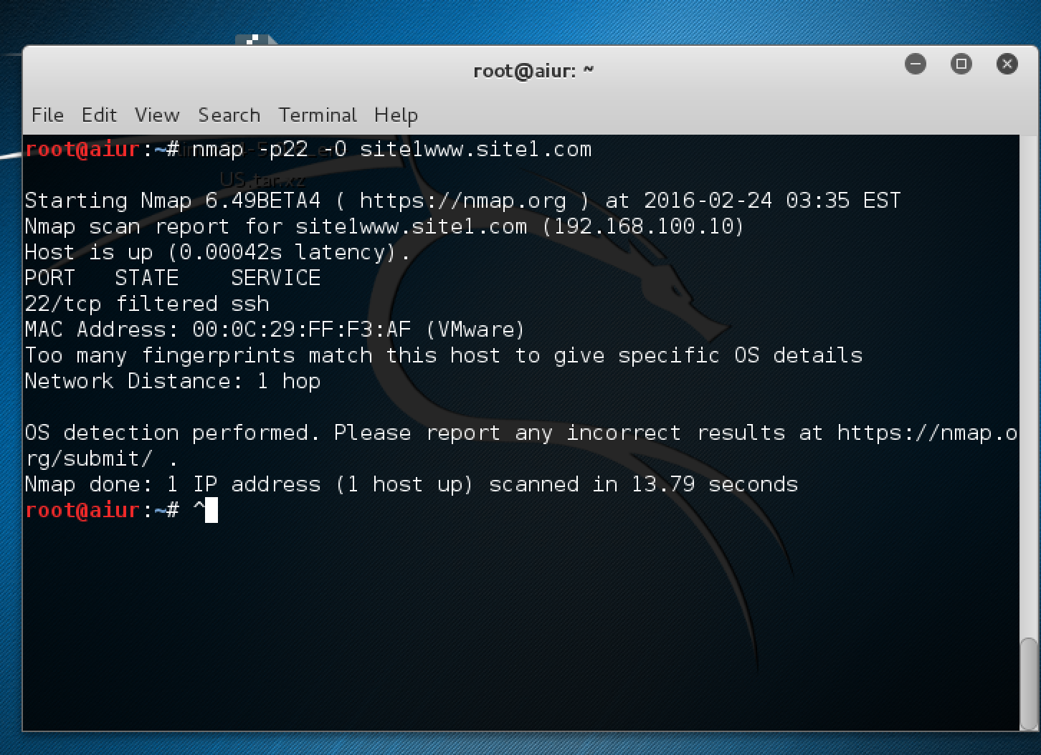

## Module 4 Lab

Here’s a Nslookup command of adobe.com so that I can find out their IP Address

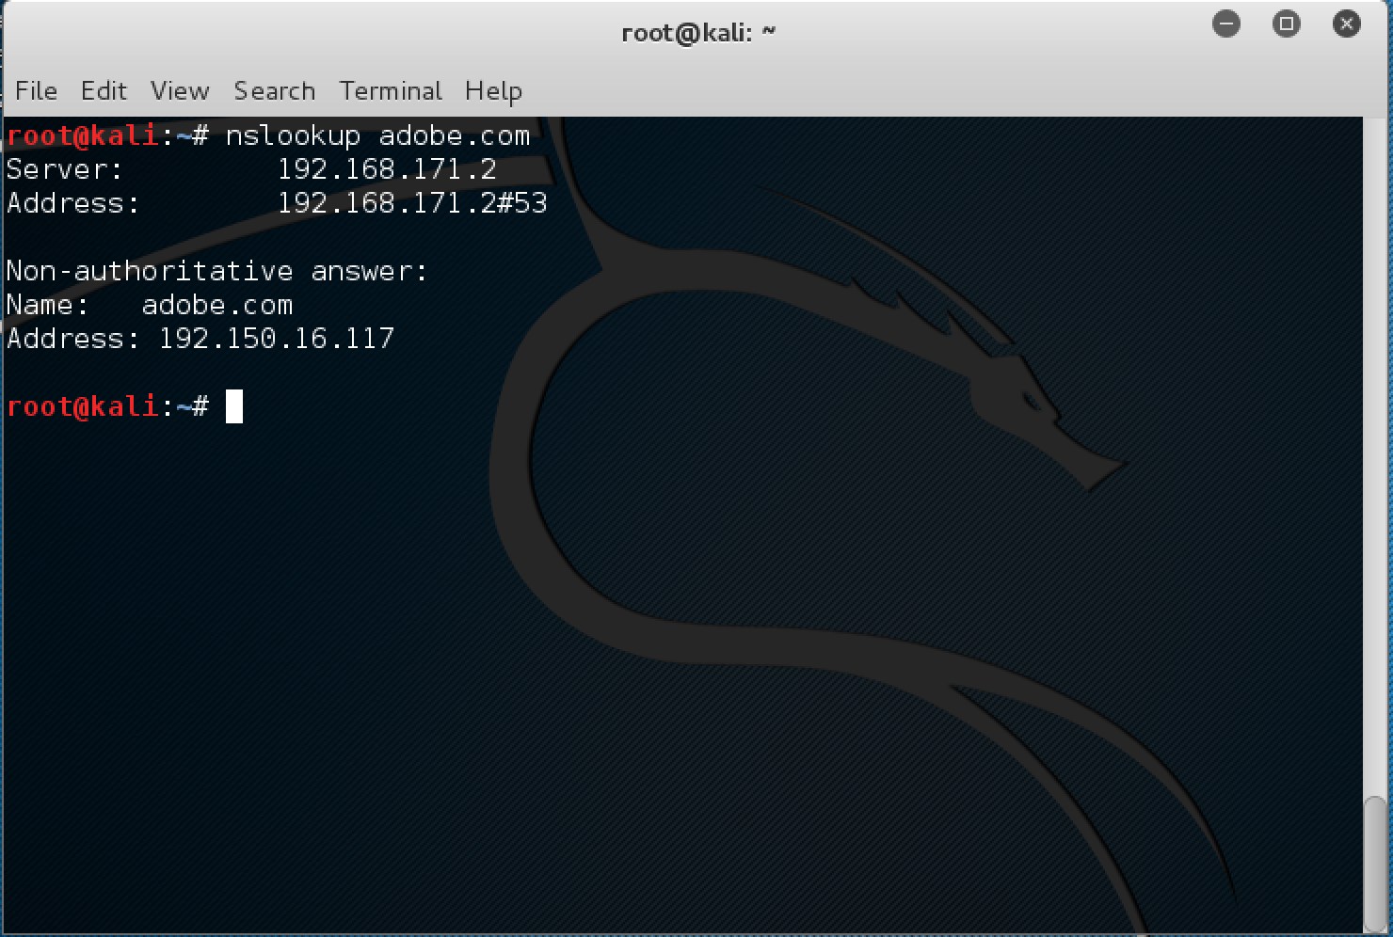

Here is my nmap scan of Adobe systems. The only ports are that are open are the internet ports, 80 and 443. I also did a stealth scan and fingerprint scan and recieved the same results. These are their only 2 ports open. This is great for their organazation because a hacker would not have much access to any other ports.

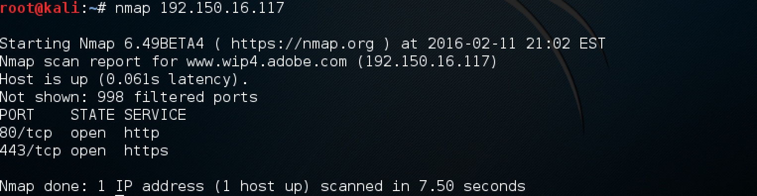

## Module 5

**Attack: Eavesdropping on Telnet**

Create a screenshot showing the captured Telnet stream and place it in your lab portfolio.

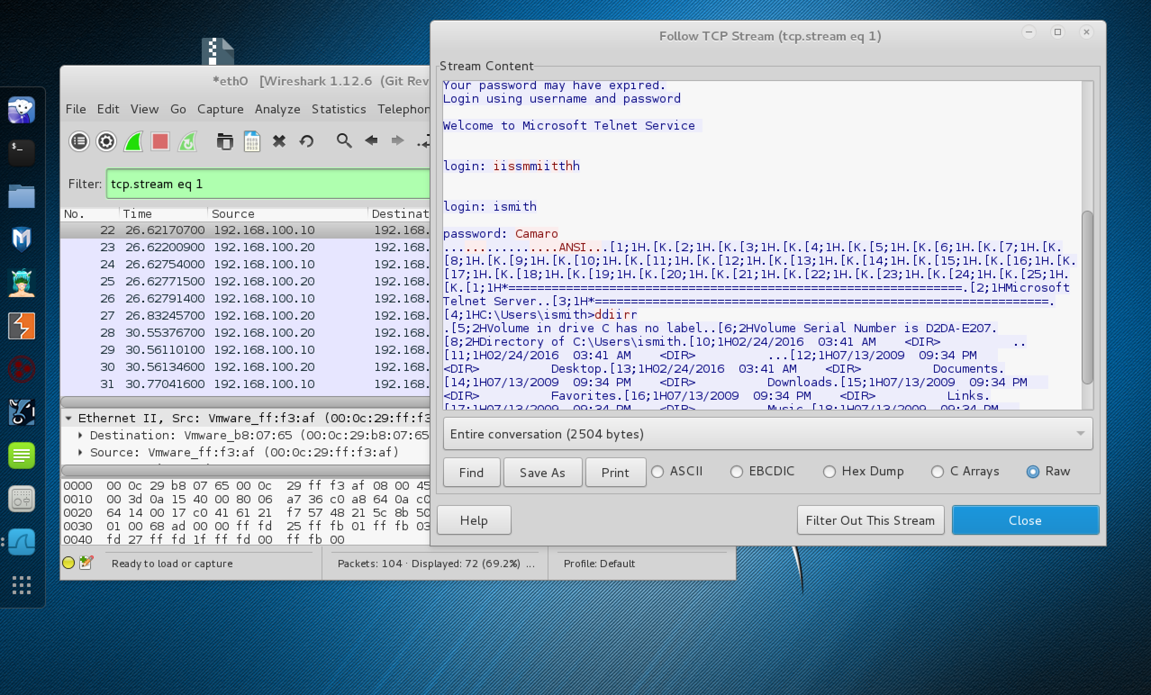

## Module 6

**Windows 7 VM**

Below is a screenshot of my Windows 7 VM with password enabled. 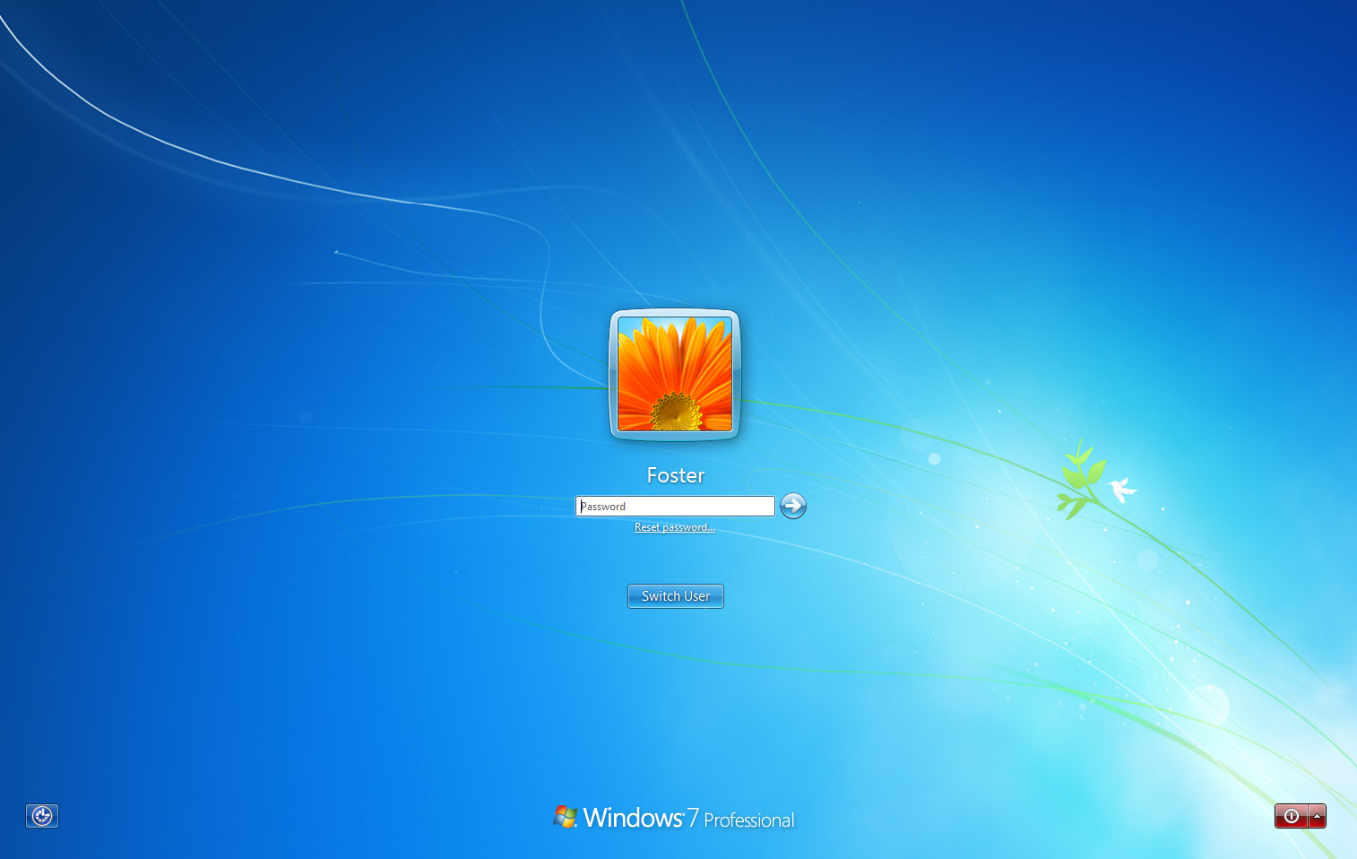

I then booted a windows password and registry editor and cleared the password. Below is also a list of the users on the comp.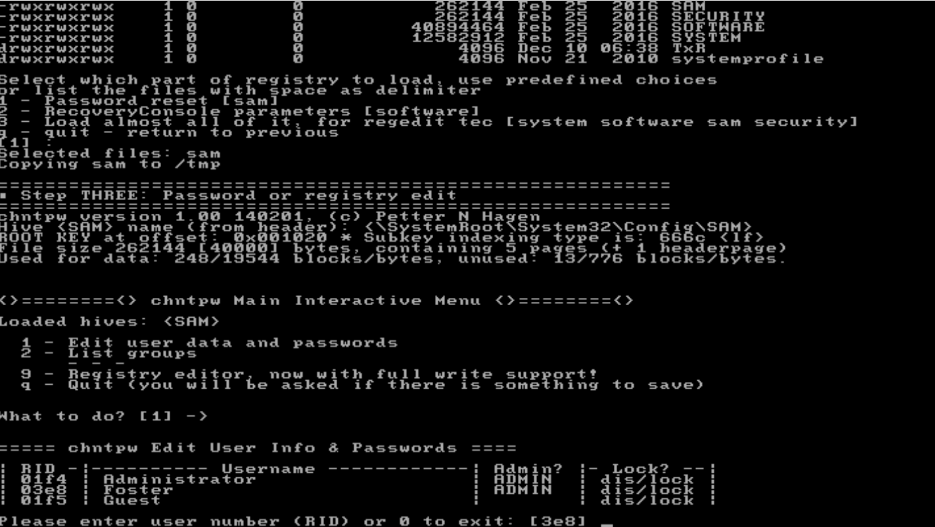

The password was then cleared and i could freely access the VM with no issues

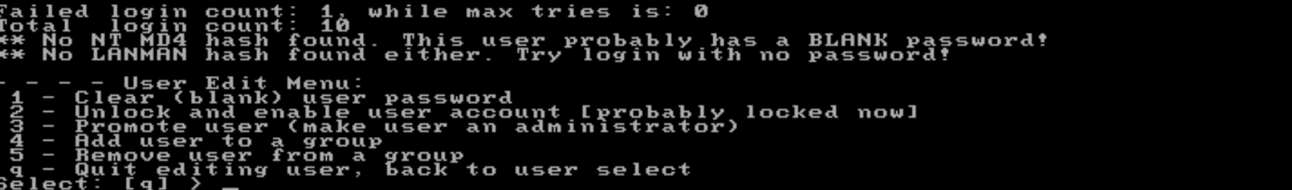

**Windows Server 2008VM**

Below is a screenshot of my Windows Server 2008 VM with password enabled.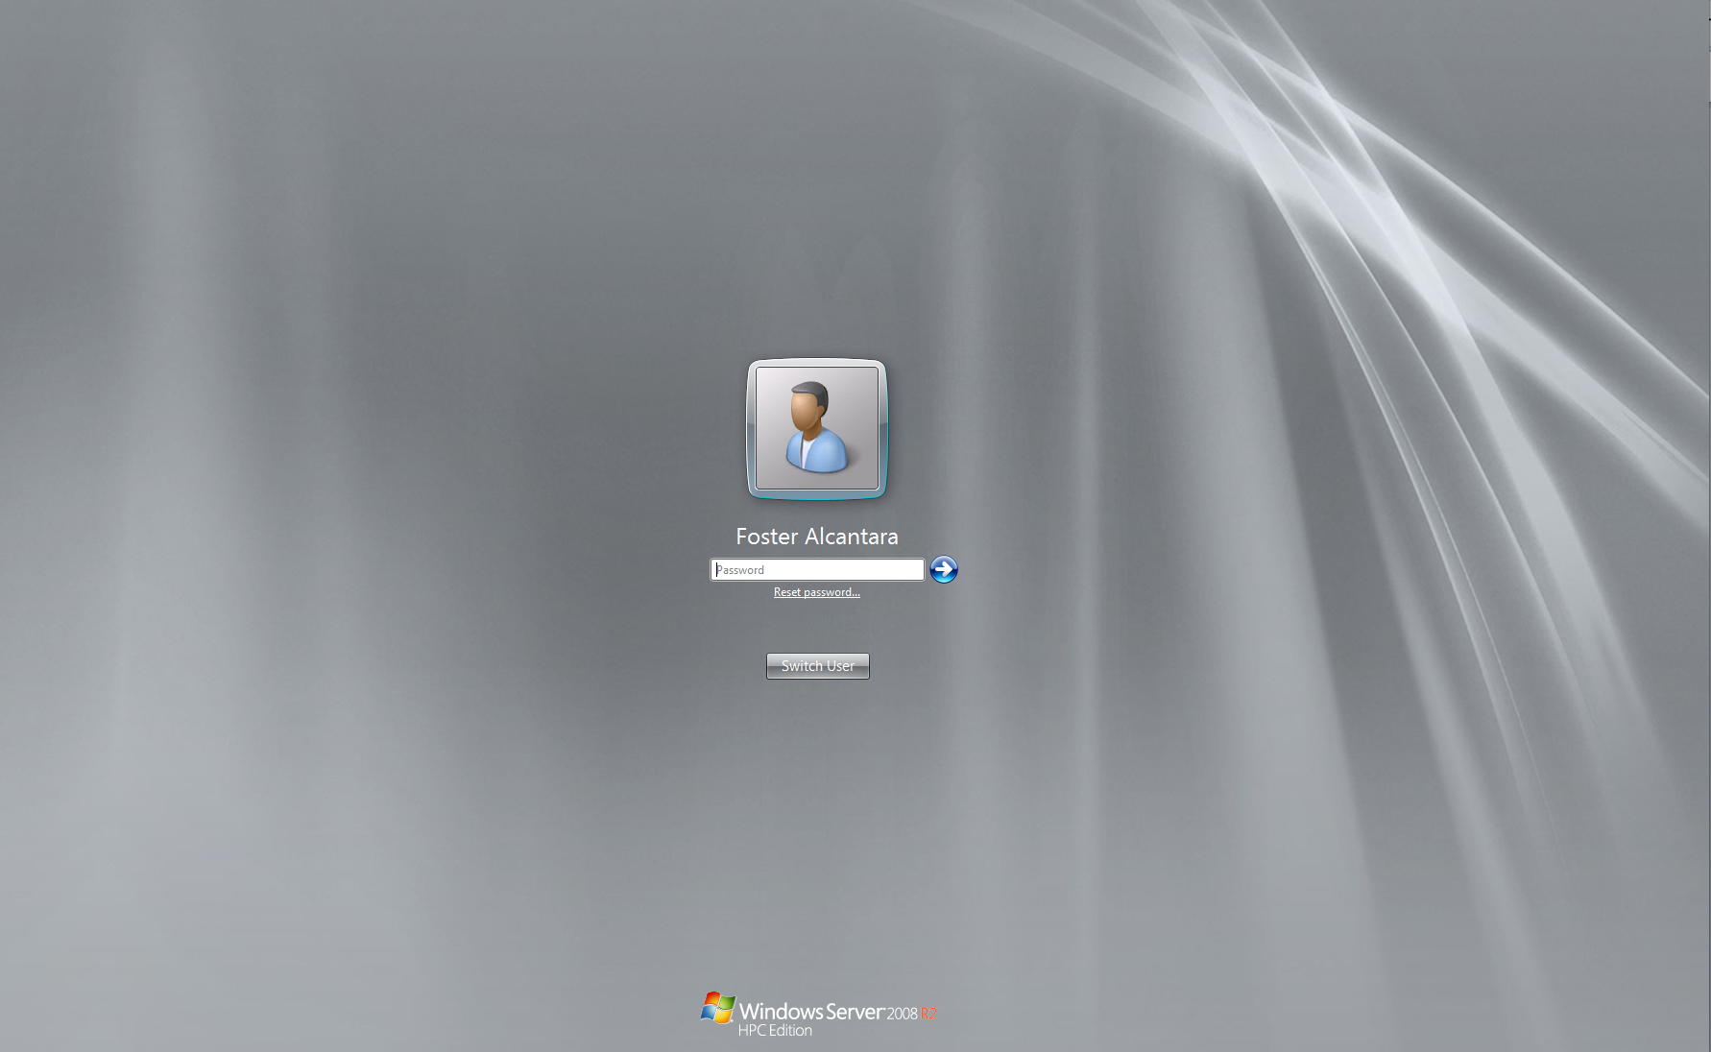

I then booted a windows password and registry editor and cleared the password. Below is also a list of the users on the comp.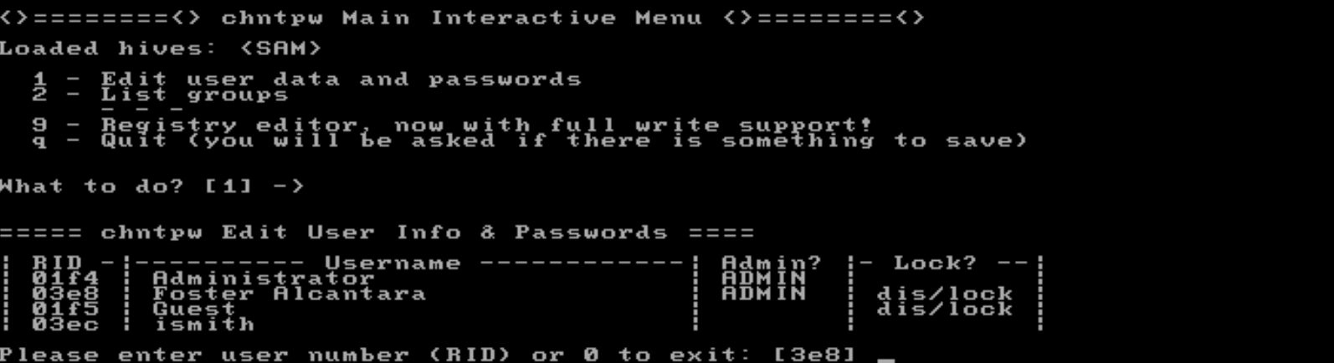

After the password was cleared i rebooted the VM and did not need to log in.

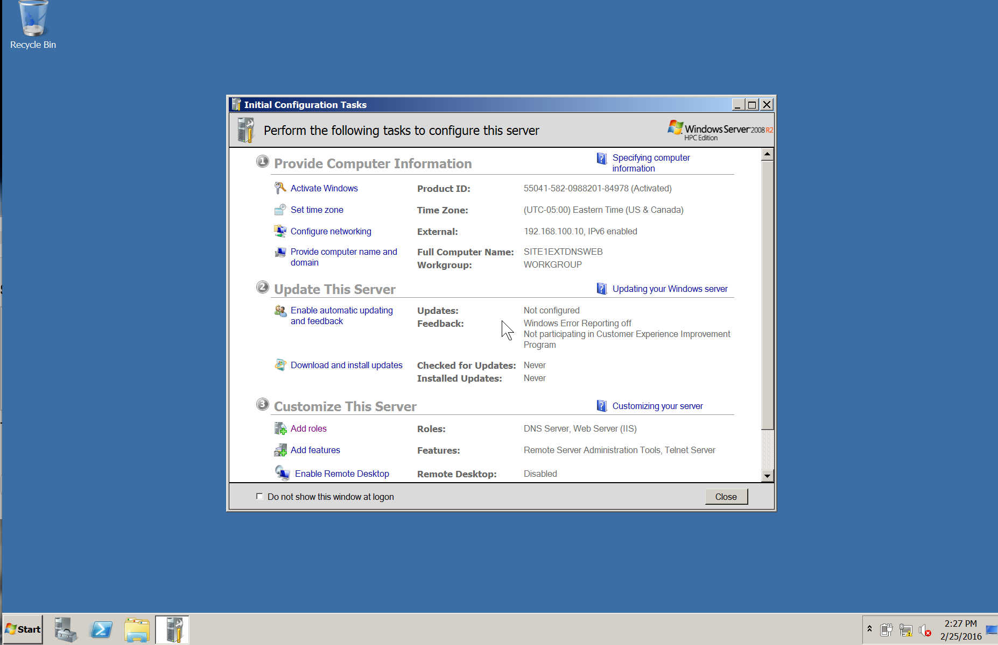

## Module 7

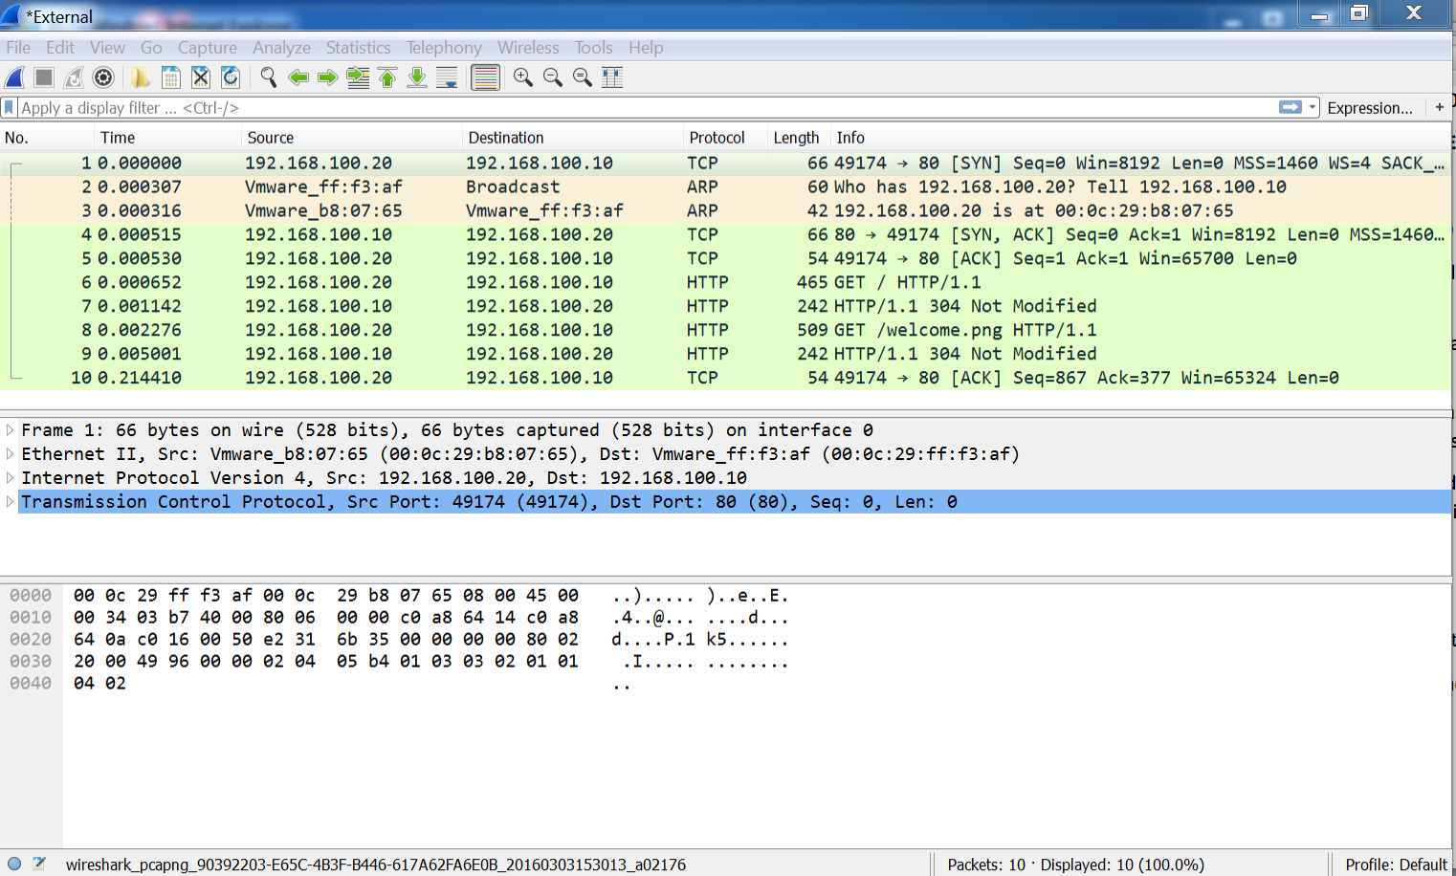

1. **Description of capture process**

In order for me to get the capture at all first, I needed to install wireshark on my Windows 7 VM. I then opened it up as well as my windows server VM. I then established a connection by opening up Internet explorer and accessing the web server. The three-way handshake popped up and I then ended the capture.

1. **Description of three-way handshake process**

The TCP 3 way handshake is when 2 hosts want to communicate with each other. Host A sends Host B a packet wanting to communicate, Host B then returns the packet with a SYN, finally Host A acknowledges that Host B would like to communicate as well so Host A sends a third packet.

**3. An explanation describing how a hacker could use the vulnerabilities in TCP/IP to facilitate IP Spoofing, a connection hijacking, and a TCP?SYN Attack**

**Ip Spoofing**- A hacker could establish a tcp connection using a man in the middle attack and from there use source routing.

**Connection hijacking**- A hacker desynchronizes packets, then sends the packets to the victim and if the victim accepts the packet the connection has been high jacked.

**TCP/SYN**- A hacker takes advantage of a three-way handshake in session and starts a syn flood by sending massive amounts of syn flags.

1. **A description of some steps that could be taken by the client to protect against these types of attacks**

* -Modify the default timer values to disrupt or avoid TCP SYN attacks.
* Increase the number of simultaneous connections a computer can handle.
* Reduce the time limit for listening for replies to the SYN/ACK in the three-way  handshake.
* Change the method used to generate sequence numbers to make sequence guessing more challenging. Use a random number generator (RNG) to create part of the algorithm that arrives at the ISN.
* Implement firewall rules to block spoofed packets from entering the intranet through the Internet or vice versa.

## Module 8

Module 8 Redirection of traffic

Editing my host file so that when I type [www.mybank.com](http://www.mybank.com) it will redirect to my web server page.

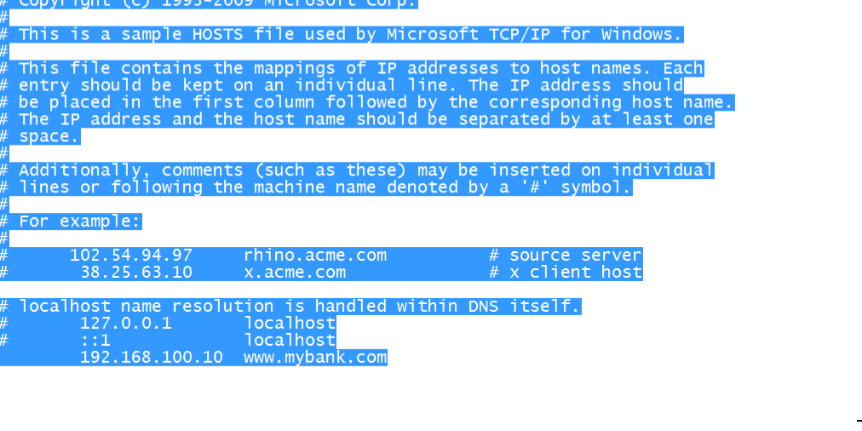

When I enter [www.mybank.com](http://www.mybank.com) I am redirected to my web server page.

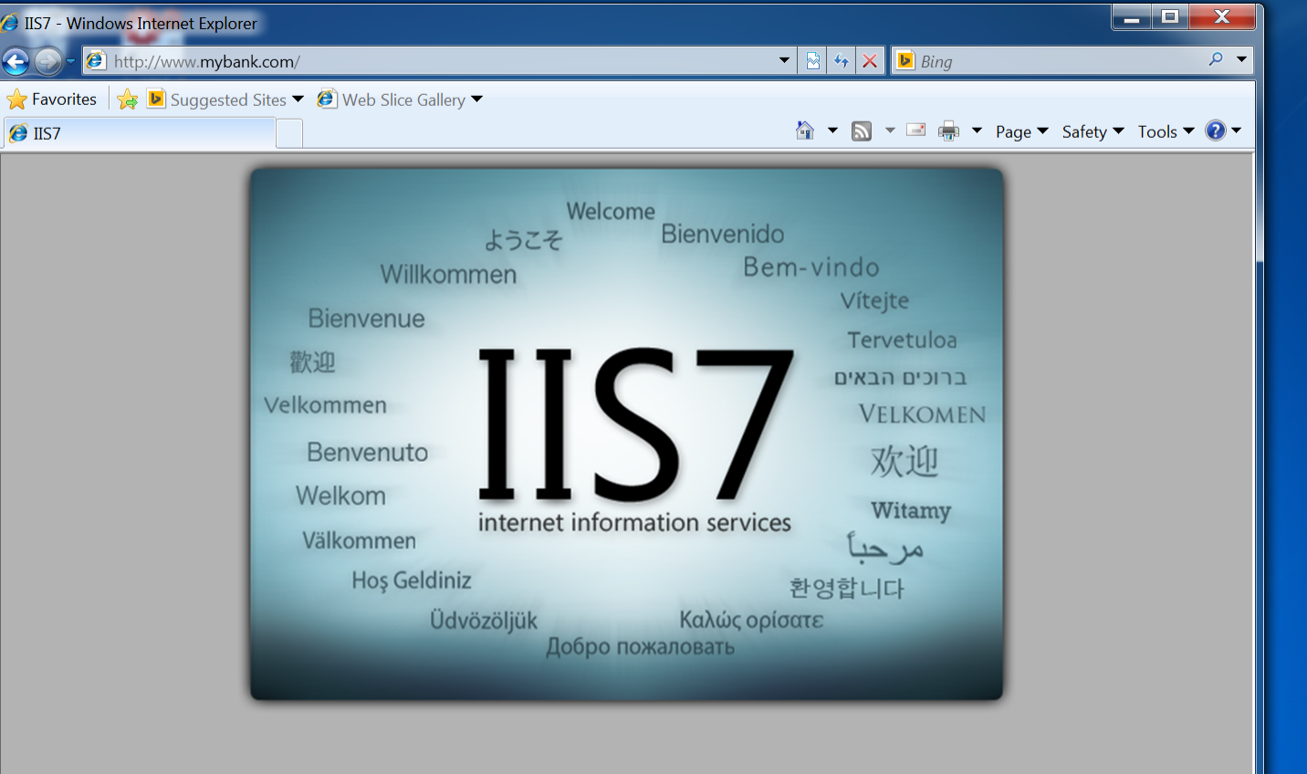

**Redirecting with the Routing Table**

Routing table

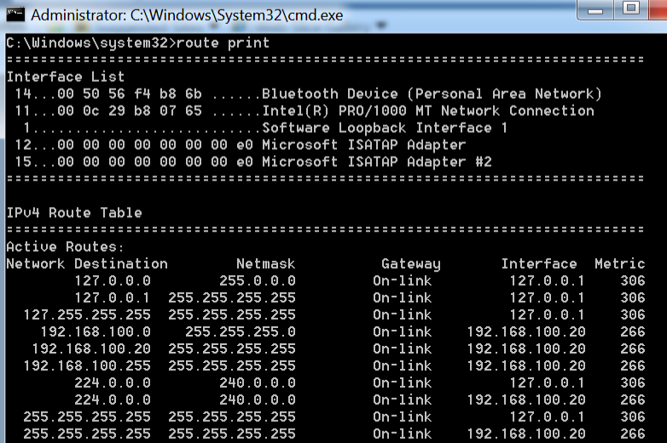

## Module 10

**Target**: Adobe Systems

**Need**: Users need to know if a file is safe to download.

**Objective**: The user will know how to identify if a file is harmful to their PC.

**Implementation**: Their discussion on free software that will quickly scan a file you have downloaded it before you open it. Examples on how to scan and which software you should download. In total this training should take about an hour to an hour and 30 minutes.

In order to prepare the company for this training program, a memo along with an email will be sent out to all employees. The text will say “Mandatory” because it’s important to keep company assets safe but as well your own personal assets. This document is a 2 weeks’ notice of a mandatory training program that all employees will attend. The company will assign 5 of their best IT staff to carry out this program. Each staff member will carry out the task of leading the program and teach the rest of the employees. They will be required to create a lesson plan, pre-test and standardized test in order to test the employees’ prior knowledge to the subject and new. If an employee fails, he or she will be required to take the program again along with the tests until the pass with an 80 or above. The tests will be 20 questions all multiple choice based on everything that was discussed in the program.

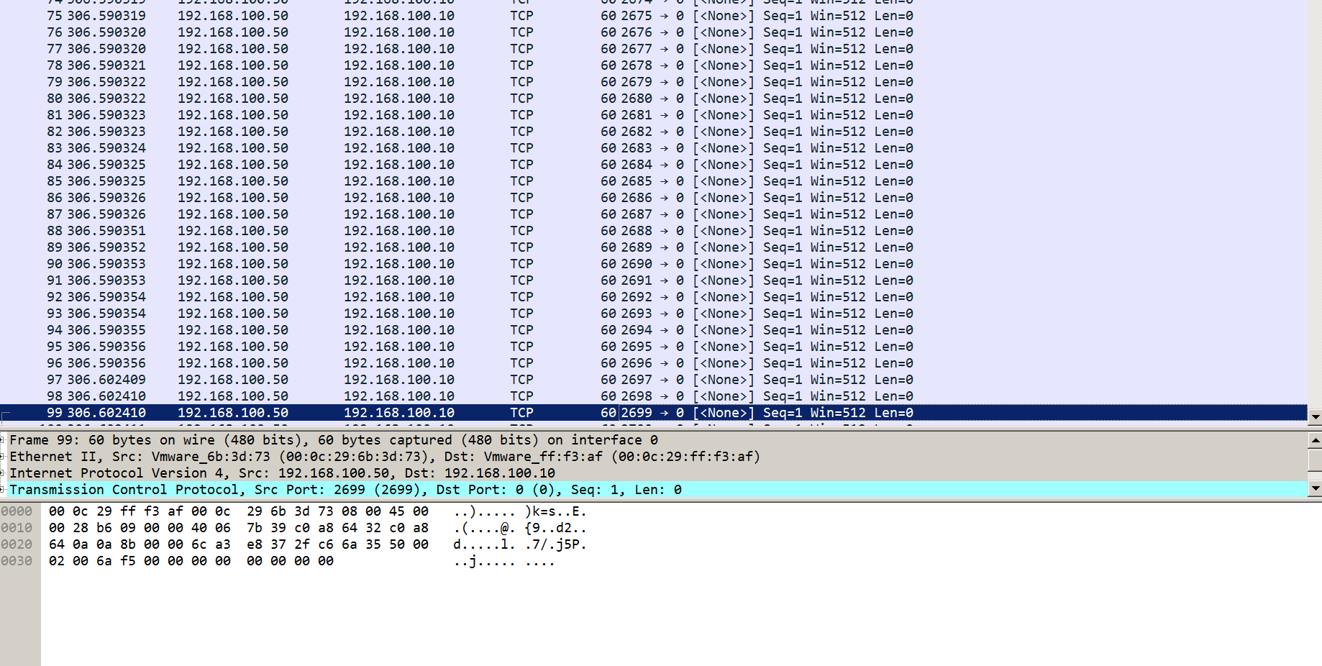

## Module 11

This screenshot is the result of the first denial of service attack I conducted on my Windows 2008 server.

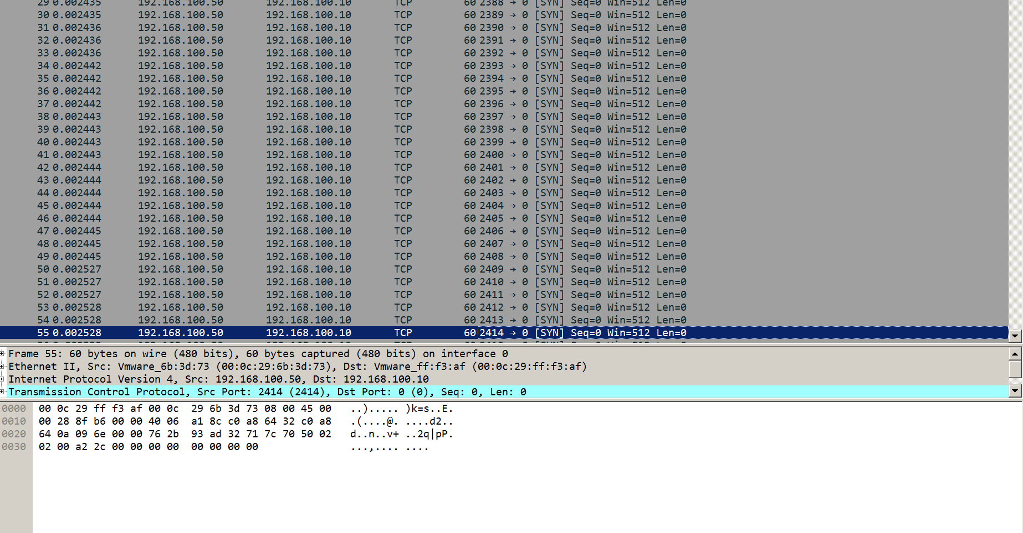

This is a screenshot of the second attack I conducted called the half/open attack. I left this attack running on for about a minute and the amount of SYN packets the victim received was just out of this world.

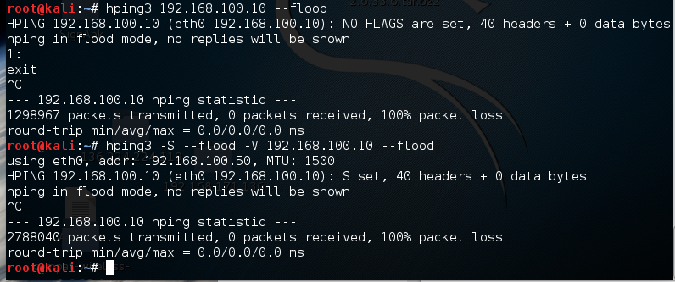Finally this screen shots shows the commands I used in order to conduct both attacks on the victim.